Figure 1
MERCOSUR Project Participant Card
(according to statistics for 2025)

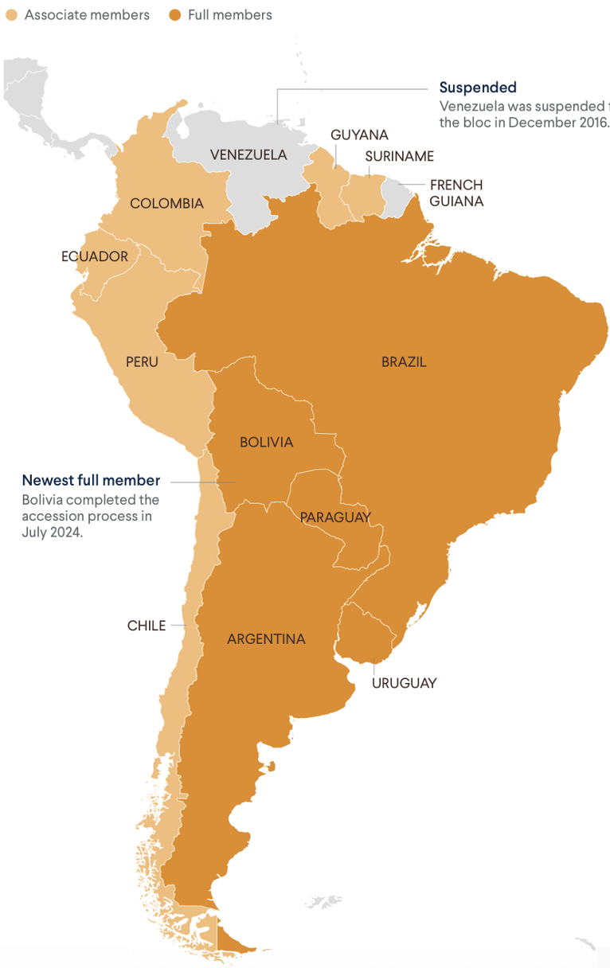

Source: CFR.org Editors. Mercosur: South America’s Fractious Trade Bloc. – 12 December 2024. URL: https://www.cfr.org/backgrounder/mercosur-south-americas-fractious-trade-bloc#chapter-title-0-3 (Accessed 12. 05. 2025).

Table 1

MERCOSUR's main foreign trade partners (calculated as a percentage)
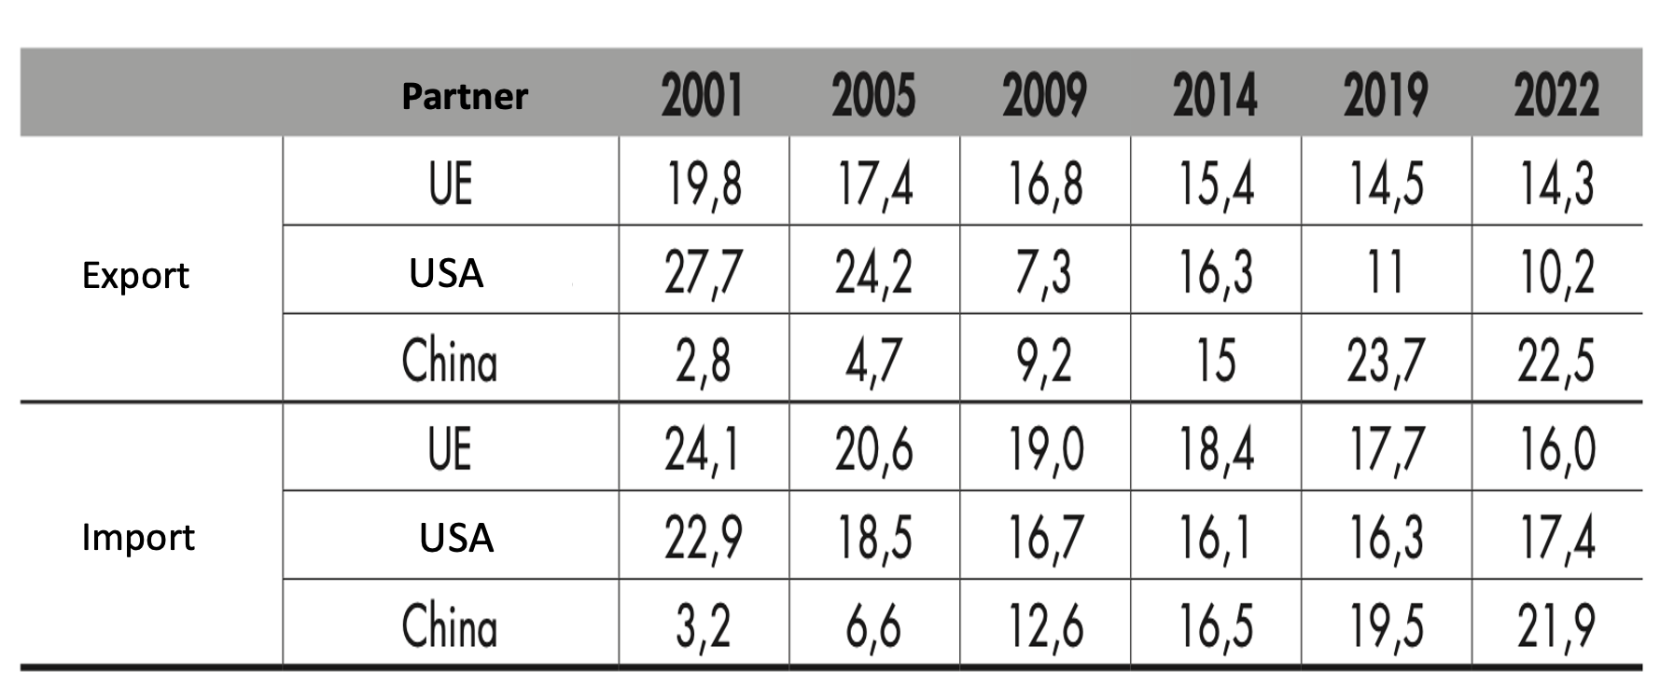 Source: [Caetano, Pose 2023, p. 227].

Figure 2
The MERCOSUR project: political integration impulses (footholds) and strategic development prospects (points of growth)
Note: Compiled by the author
